1920s Jigsaw
Just as we did a little over a month ago with the Gilded Age, you will once again be teaching the class about a particular topic, in this case, the 1920s. This time, however, you are expected to put together a full and complete lesson that includes an anticipatory set, Power Point, Prezi or Google Docs presentation as well as a lesson activity.

- Anticipatory set: The goal of an anticipatory set it to get students eager to learn about your topic, engage their interest or just get them ready for what it is that you are about to teach them. Anticipatory sets could be bell ringer questions, class discussions, games, simulations, video clips, whatever it is that works best for your topic. I am more than happy to help you come up with ideas. You just need to ask!

- Lesson Presentation: This is going to be your Power Point, Prezi or Google Docs presentation. It should be no more than 4 slides. Your slides should contain key ideas that you want students to know as well as visual images to help them grasp the topic. Remember, there is a difference between good presentations and bad presentations. Based on the slides below, which is better? Why?

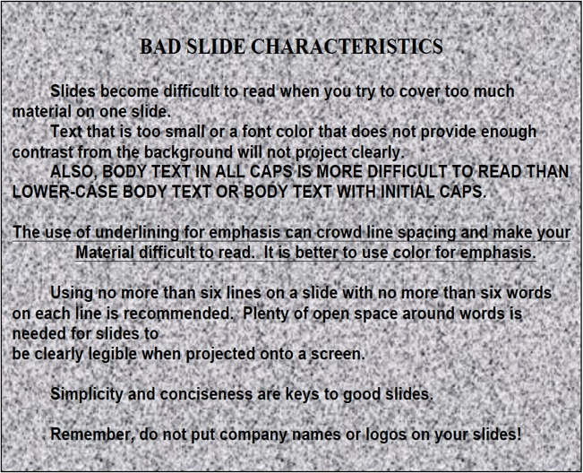

Please email me your presentations or put them on a flash drive. I would also suggest emailing them to more than one place as these things do get lost sometimes. DO NOT WAIT TO EMAIL IT JUST BEFORE YOUR PRESENTATION! Chances are, I won’t get it in time and you’ll take a zero.

- Lesson Activity: At the end of each lesson, there is an activity. You will need to create an activity to accompany your lesson. You will NOT be allowed to do crossword puzzles or word searches as your activity. Your lesson activity can be a cartoon, a question in which students must provide a thought provoking response or whatever else it is you can come up with. Again, I am more than happy to help you come up with ideas. I will need your groups activity on a separate sheet of paper by Thursday as I need to put it together in a packet for each student.

These presentations are expected to be 15-20 minutes long. Yes, you read correctly. Your presentations should be engaging and you will have to work EXTREMELY hard to make sure that you meet the time frame. I suggest that when you are done, you practice your presentations to make sure that you receive a high score. You will have the next four days to work on these in class. Beginning on Thursday, I will be calling each group over to see what you have planned/give advice on things you should or should not do. The rubric is as follows:

- Anticipatory set (should engage your classmates)- 50 points
- Lesson Presentation (including Power Point/your ability to teach) - 75 points
- Lesson Activity (should be something that has students reflect on your lesson) - 25 points
- Presentation time (Again, should be 15-20 minutes)- 50 points

This is a total of 200 points. Once everyone’s lesson activities are put together, each packet will be worth 120 points (110 points for the activities and 10 points for your notes on your section). You are going in order of the list that is attached. It can not be changed to a different day so if somebody doesn’t show up in your group or you forgot something, too bad. Presentations will begin next Monday. We will be doing 3 presentations per day.

