Doc A
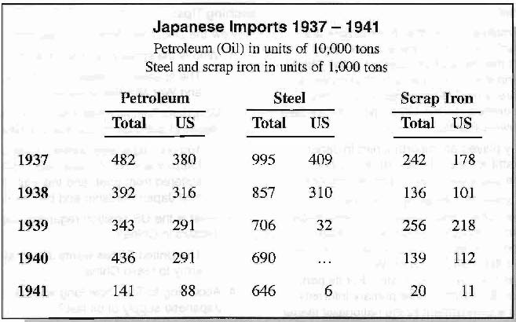
Doc B
Source: Hideki Tojo, comments at Imperial Conference, November 5, 1941. In Akira Iriye, Pearl Harbor and the Coming of the Pacific War, Bedford/St. Martins Press, 1999.
Note: Tojo was both Prime Minister and War Minister of Japan. These comments were made in a closed meeting of Japan's top government and military leaders in the presence of the Emperor.
"The United States has not conceded a single point; it simply makes strong demands on Japan.
... What they insist upon is Japan's acceptance of the principle of the withdrawal of troops .... As I understand it, withdrawal of our troops is retreat. We sent a large force of one million men to China, and it has cost us well over 100,000 dead and wounded, the grief of their bereaved families, hardship for four years, and a national expenditure of several billions of yen. We must by all means get satisfactory results from this.... We can expect an expansion of our country only by stationing troops. This the United States does not welcome.
...(H)ow can we let the United States do as she pleases, even though there is some uneasiness? Two years from now we will have no petroleum for military use. Ships will stop moving. When I think about the strengthening of American defenses in the Southwest Pacific, the expansion of the American fleet, ... I see no end to difficulties .... I fear that we would become a third-class nation after two or three years if we just sat tight."

