Miss. Toller’s Notebook Checklist
All notes must be taken on the RIGHT hand side of your notebooks

- You can take notes how you choose, HOWEVER, you must interact with your notes in order to earn full credit. This could be adding a summary, asking questions, drawing pictures, Marking the Text (with your notes as you will do with documents). As an example, we will be doing Cornell notes for your first set of notes.
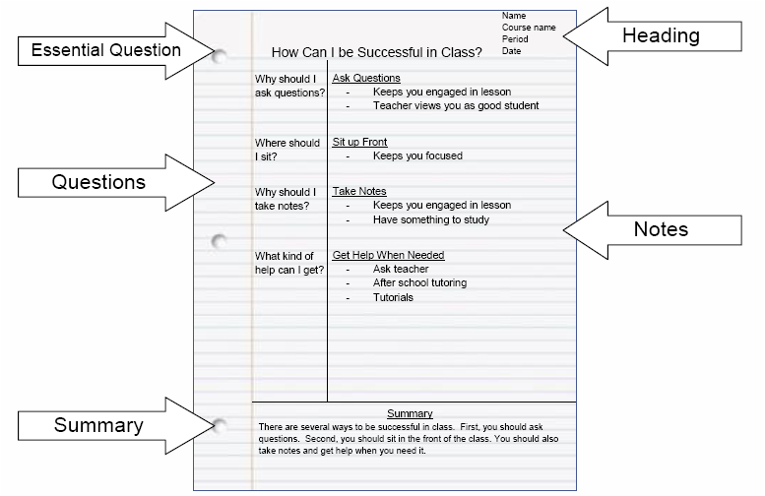
- If given fill in notes, those are to be glued into the right hand side of your notebook
All classwork, homework, worksheets, etc. will be on the LEFT hand side of your notebooks
Everything needs to have a title
Any worksheets or items you may have forgotten to record in your notebooks need to be glued in. If items are not glued in, you will lose points or I will refuse to grade your notebook until you do so.
Only glue in one sheet for each side of paper. Multiple sheets glued in on the same side of the paper will lose points.
Notebooks will be graded about every 2 weeks. The amount of points each notebook check is worth will range depending on how many notes/assignments are being graded.
Although I only grade the notebooks every two weeks, you are expected to work on your assignments during class. A new assignment will likely be given every class period, however, if you use your class time wisely, you will finish the assignment in class and NEVER have homework. Since I have had an issue with students not working on assignments during class because it “wasn’t due,” I will be instituting a stamp policy. At the end of class, I will be going around stamping class work at the end of the period for students who were using class time wisely. If a student did not finish the assignment, but was using class time to get an assignment done, they will still receive a stamp. If a student does not receive a stamp because they were wasting class time, they will lose points on the assignment when I grade it with the notebook check.

