Name: ____________________________________________________

Period 2 1920s Packet
*Make sure you staple your notes to the BACK of this packet. They are worth points!

Nativism Resurges

- Do you believe that the Nativism Resurges (anti-immigrant position) was cruel and unjust, or reasonably just? (2-4 sentences)

________________________________________________________________________________________________________________________________________________________________________________________________________________________________________________________________________________________________________________________________________________________________________________________________________________

- What was a time in history when Nativism Resurges could have been called reasonably just due to fear in the eyes of Americans?

________________________________________________________________________________________________________________________________________________________________________________________________________________________________________________________________________________________________________________________________________________________________________________________________________________

Controlling Immigration

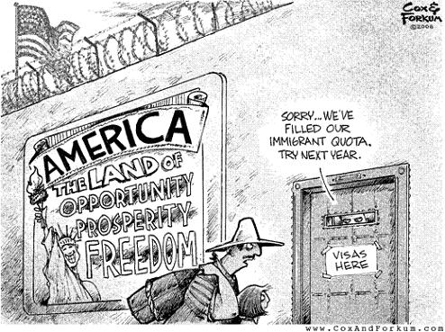

Explain what symbolic devices are used in this picture and what they mean

________________________________________________________________________________________________________________________________________________________________________________________________________________________________________________________________________________________________________________________________________________________________________________________________________________________________________________________________________________________________
New Morality

- Why were people trying to insinuate an ideal marriage?

____________________________________________________________________________________________________________________________________________

- How was it implied? Was it discrete?

____________________________________________________________________________________________________________________________________________

- Did the new morality have an affect on people’s lives?

__________________________________________________________________________________________________________________________________________________________________________________________________________________

Fundamentalist Movement

Bell Ringer: Based on the information you know so far, what are your thoughts on the fundamentalist movement. Why?

____________________________________________________________________________________________________________________________________________________________________________________________________________________________________________________________________________________________________________________________________________________________________________________________________________________________________

- Have your thoughts on this movement changed? Why or who not?

________________________________________________________________________________________________________________________________________________________________________________________________________________________________________________________________________________________

Prohibition

Draw a political cartoon that reflects the prohibition movement. Must be in color!

Art and Literature

- Which famous writing was adapted into a feature length film?

  - The Great Gatsby
  - A Farewell to Arm
  - The Sun also Rises
  - Whom the Bell Tolls

- What was the age of music dubbed as?

  - Age of Realism
  - Age of Surrealism
  - Age of Symbolism
  - Age of Post Impressionism

- What do surrealists base their art off of?

  - Families
  - Nature/Surroundings
  - Politics
  - Dreams/Personal experiences

Popular Culture

Create a baseball card about your favorite sport/movie/music artist/radio show

Harlem Renaissance

If We Must Die, Claude McKay

If we must die, let it not be like hogs
Hunted and penned in an inglorious spot,
While round us bark the mad and hungry dogs,
Making their mock at our accurséd lot.
If we must die, O let us nobly die,
So that our precious blood may not be shed
In vain; then even the monsters we defy
Shall be constrained to honor us though dead!
O, kinsmen! we must meet the common foe!
Though far outnumbered let us show us brave,
And for their thousand blows deal one death-blow!
What though before us lies the open grave?
Like men we'll face the murderous, cowardly pack,
Pressed to the wall, dying, but fighting back!

- Why does McKay use “we, us?”

__________________________________________________________________________________________________________________________________________________________________________________________________________________

- Who is the “hungry dogs” in this poem??

____________________________________________________________________________________________________________________________________________
- How does this poem correspond with the Harlem Renaissance?

____________________________________________________________________________________________________________________________________________________________________________________________________________________________________________________________________________________________________________________________________________________________________________________________________________________________________

African American Politics

- What three things did Oscar De Priest accomplish?

- Provide pensions for formerly enslaved African Americans, made NAACP and worked alongside Lincoln
- Ban Lynching, declare Lincoln’s birthday a National Holiday, provide pensions for formerly enslaved African Americans
- Worked alongside Marcus Garvey, provide pensions to formerly enslaved African Americans

- NAACP stands for…?

- National Association of the Apple of Colored People
- National Association Assertive of Colored People
- National Association for the Advancement of Colored People

- The Pan-American Flag is…?

- Red, black and green
- Purple, blue and yellow
- White, grey and blue

Harding Administration

- What factors caused the Harding Administration to fall into chaos and corruption?

____________________________________________________________________________________________________________________________________________________________________________________________________________________________________________________________________________________________________________________________________________________________________________________________________________________________________

The Coolidge Administration

Compare and contrast the Harding and Coolidge administration using the Vinn diagram on the following page:

Rise of New Industries

- Why is the rise of new industries important?

________________________________________________________________________________________________________________________________________________________________________________________________________________________________________________________________________________________________________________________________________________________________________________________________________________

Consumer Society

Choose the cheesiest product you can think of and try selling it for the most money. Create an advertisement for that product. Must be in color!

Farm Crisis

- How is the situation for farmers now similar to what farmers went though in the 1920’s?

____________________________________________________________________________________________________________________________________________________________________________________________________________________________________________________________________________________________________________________________________________________________________________________________________________________________________

Promoting Prosperity

- What were the economic differences and benefits between the Mellon Program and Herbert Hoovers cooperative individualism?

____________________________________________________________________________________________________________________________________________________________________________________________________________________________________________________________________________________________________________________________________________________________________________________________________________________________________

Trade and Arms Control

- Do you think these treaties were enough to solve this problem? What other treaties or regulations could have been adopted to reduce/control warfare?

____________________________________________________________________________________________________________________________________________________________________________________________________________________________________________________________________________________________________________________________________________________________________________________________________________________________________

