Name: ________________________________ Period: ________
Women’s Suffrage DBQ
*Use the SOAP Method for both of these documents before answering the question in the left hand side of your notebook.
Document B:
…But we are assembled to protest against a form of government existing without the consent of the governed - to declare our right to be free as man is free, to be represented in the government which we are taxed to support, to have such disgraceful laws as give man the power to chastise and imprison his wife, to take the wages which she earns, the property which she inherits, and, in case of separation, the children of her love; laws which make her the mere dependent on his bounty. It is to protest against such unjust laws as these that we are assembled today, and to have them, if possible, forever erased from our statute books, deeming them a shame and a disgrace to a Christian republic in the nineteenth century. We have met to uplift woman's fallen divinity upon an even pedestal with man's. And, strange as it may seem to many, we now demand our right to vote according to the declaration of the government under which we live…
Source: Elizabeth Cady Stanton, Seneca Falls Key Notes Address (July 19, 1848)

Document D:
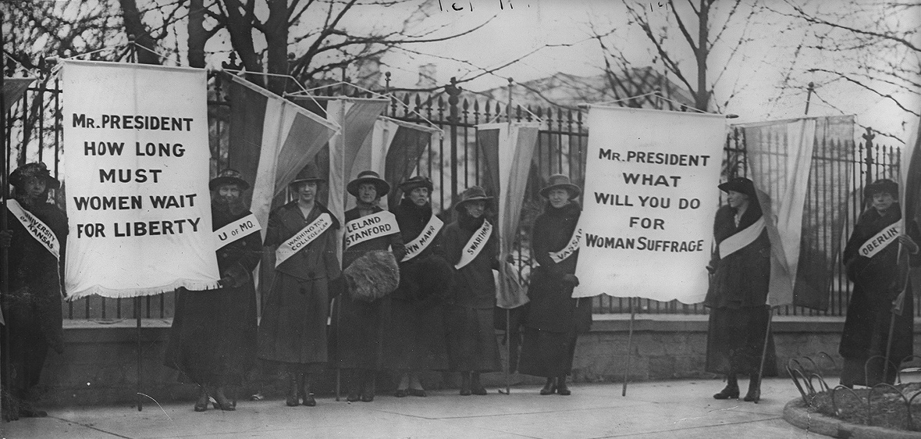

Question: Why were women so keen to be given the right to vote in America? Use both documents to support your answer as well as outside information.

________________________________________________________________________________________________________________________________________________________________________________________________________________________________________________________________________________________________________________________________________________________________________________________________________________________________________________________________________________________________________________________________________________________________________________________________________________________________________________________________________________________________________________________________________________________________________________________________________________________________________________________________________________________________________________________________________________________________________________________________________________________________________________________________________________________________________________________________________________________________________________________________________________________________________________________________________________________________

