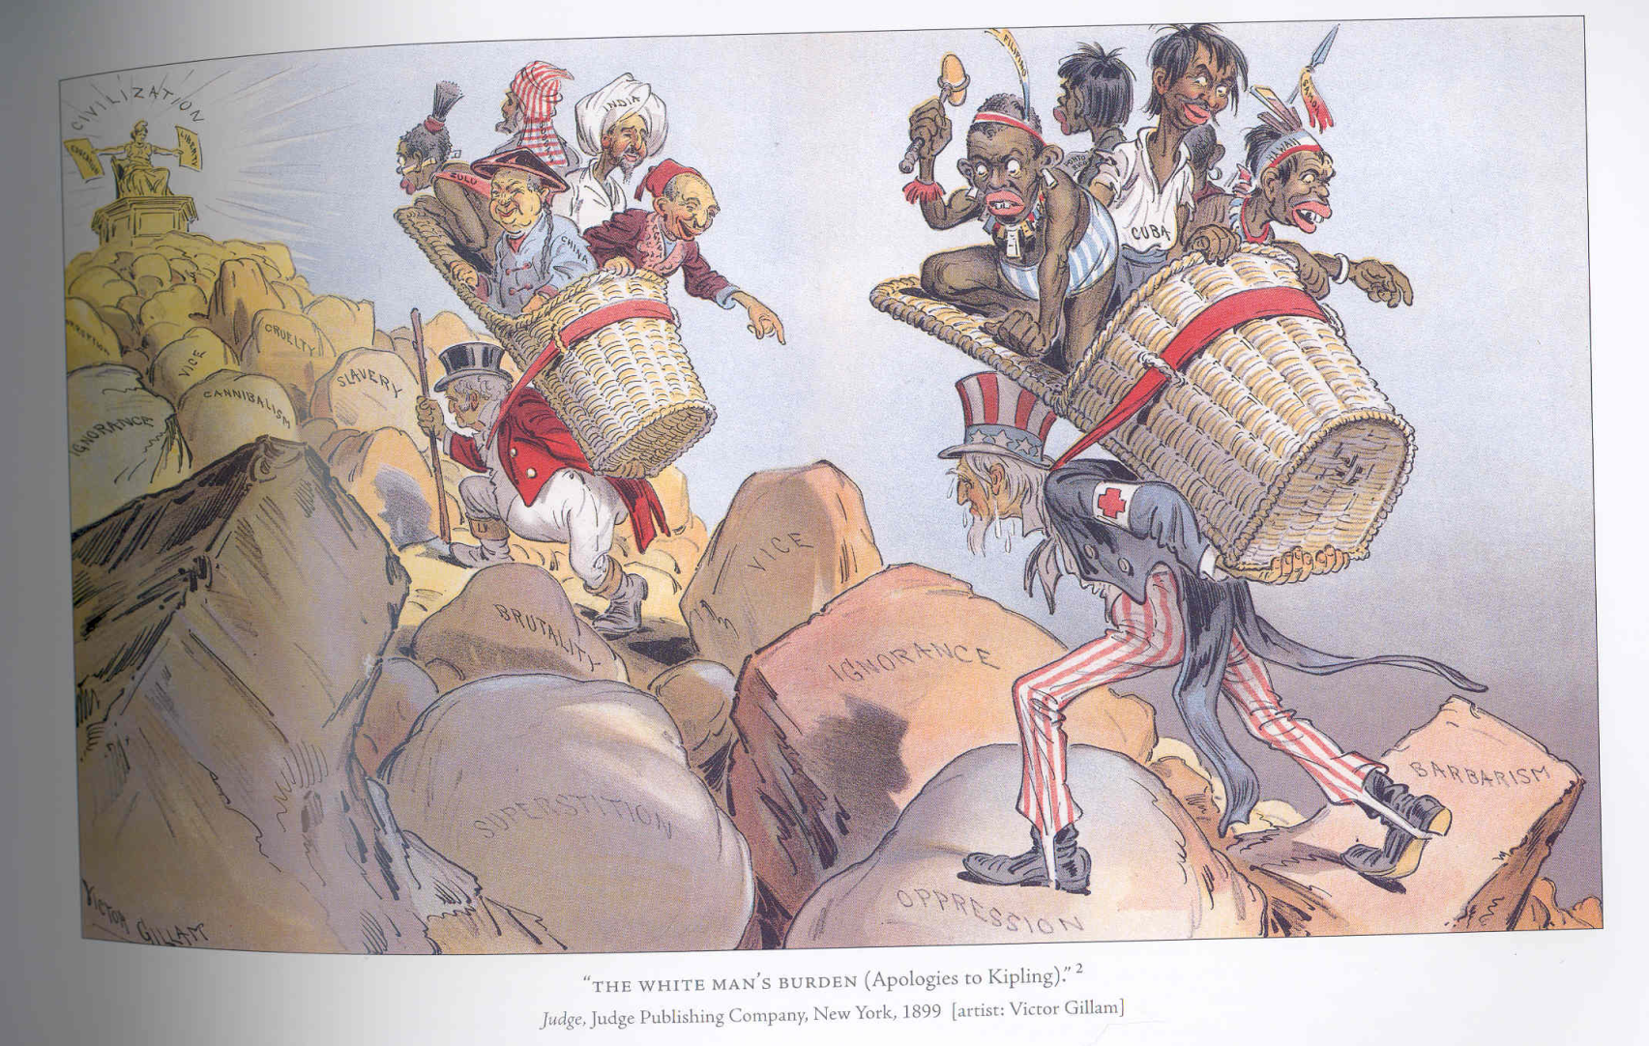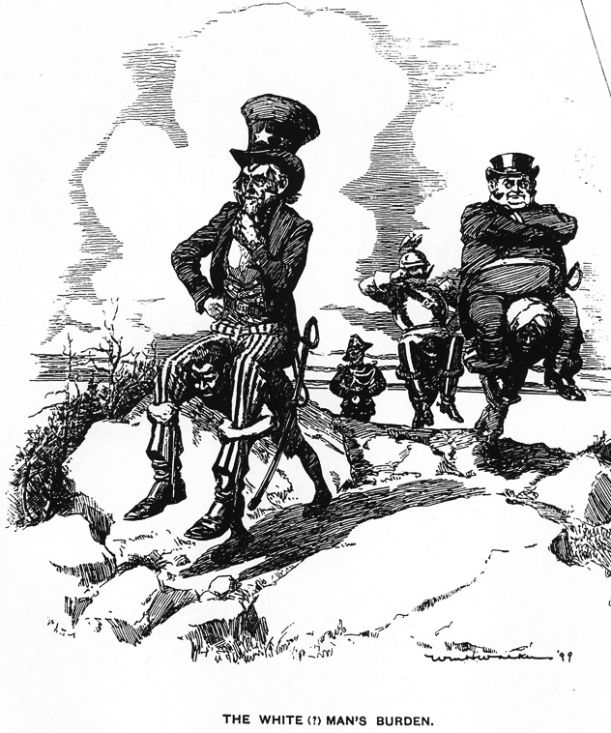

What symbolism is being used to support this message?

What stance is this picture showing regarding the White Man’s Burden?

What is happening in this picture?

What is happening in this picture?

What stance is this picture showing regarding the White Man’s Burden?

What symbolism is being used to support this message?

How might Rudyard Kipling’s childhood have influenced his feelings towards imperialism?

What does Kipling mean when he calls the conquered people “Half-devil and half-child”?

What positive things does imperialism bring?

Re-phrase the last two lines of this stanza.

“THE WHITE (?) MAN’S BURDEN”

Wm. H. Walker, 1899

***The White Man’s Burden***

Rudyard Kipling, 1899

(excerpt)

Take up the White Man's burden--  
Send forth the best ye breed--  
Go bind your sons to exile  
To serve your captives' need;  
To wait in heavy harness,  
On fluttered folk and wild--  
Your new-caught, sullen peoples,  
Half-devil and half-child.  
  
…Take up the White Man's burden--  
The savage wars of peace--  
Fill full the mouth of Famine  
And bid the sickness cease;  
And when your goal is nearest  
The end for others sought,  
Watch sloth and heathen Folly  
Bring all your hopes to naught.  
  
…Take up the White Man's burden--  
Have done with childish days--  
The lightly proffered laurel,  
The easy, ungrudged praise.  
Comes now, to search your manhood  
Through all the thankless years  
Cold, edged with dear-bought wisdom,  
The judgment of your peers!

“THE WHITE MAN’S BURDEN (APOLOGIES TO KIPLING)”

Victor Gillam, 1899

In what ways might imperialism test the “manhood” of conquering nations?