There are many mysteries in American history, and one of the most contested is that of its founding. Various groups claim to have found this land that would one day become home to the United States of America. But who should really deserve the credit? Whose story is the most valid? Should the title go to those who were here first? Or those who did the most with it?
Today you will become a historical detective. As a group, you will analyze various accounts of the discovery and settlement of the Americas. You will determine which group deserves the credit as the “Founders of America” and present your findings to the class via a poster. Your goal is to prove your theory using the documents provided and your historical detective skills. Note: All sources are secondary sources based on encyclopedia entries.
Prompt:
Who should be credited with the “Founding of America”?
Instructions:
- Read through and analyze the nine accounts of the discovery and settlement of the Americas. You will do this individually before joining a group. Take notes on each document using a separate sheet of paper.
- As a group, decide who you think should be given the credit for discovering America.
- Decide which documents best support your theory. Be able to explain why you chose those documents.
- Create a poster to illustrate your theory.
Poster Requirements:
- Title (“Who Discovered America?”)
- Theory (e.g. “We believe ________ deserves the credit for the founding of America.”)
- Selected documents/evidence to support your theory
- Visuals to help illustrate your theory

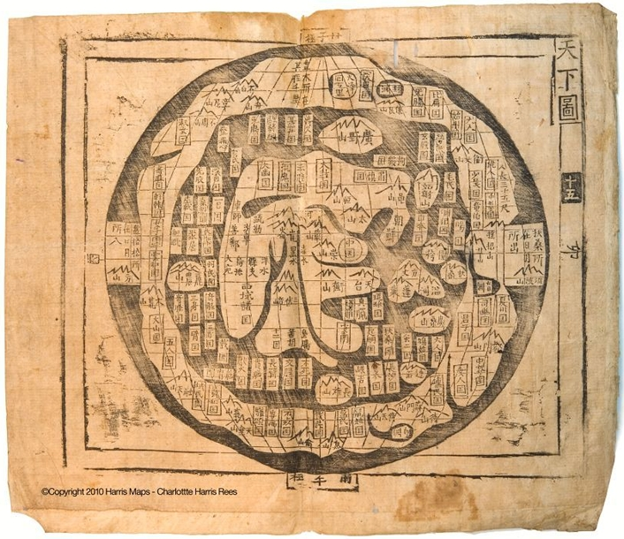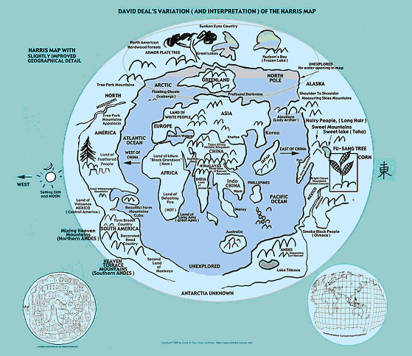
The Harris Map (top) and interpretation (bottom)

The Chinese – In 1972, Dr. Hendon M. Harris, Jr. discovered an ancient Chinese map book that contained a map of the fabled land “Fu Sang” (similar to the Western city of Atlantis). Through his research and analysis, he determined the map detailed new lands west of Europe and East of Asia – what are now North and South America. He believed this proved that Chinese explorers had reached and explored the American continents far before Columbus.
Estimated Arrival: 1418
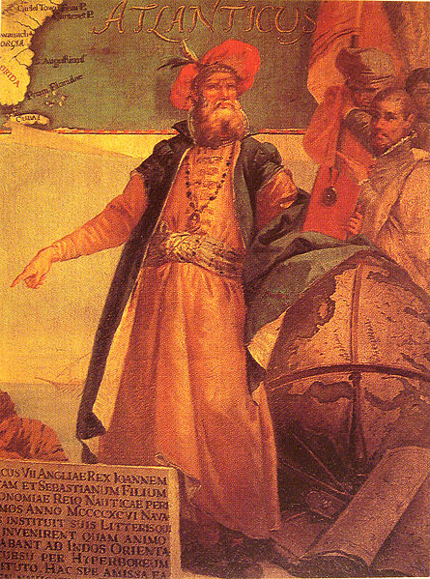
John Cabot in traditional Venetian garb by Giustino Menescardi (1762).

John (Giovanni) Cabot – Several expeditions had been sent out to look for Hy-Brazil, an island said to lie somewhere in the Atlantic Ocean according to Celtic legends. Leaving England, the expedition sailed past Ireland and across the Atlantic making landfall somewhere on the coast of North America on June 24, 1497. The exact location of the landfall has long been a matter of great controversy, with different communities vying for the status of being the location of the landing. No contact was made with any native people, but they found the remains of a fire, a human trail, nets and a wooden tool. The crew only appeared to have remained on land long enough to take on fresh water and to raise the Venetian and Papal banners and claim the land for the King of England, while recognizing the religious authority of the Roman Catholic Church. Nearly everything that is known about Cabot’s 1497 voyage comes from four short letters (none written by Cabot himself) and a brief chronicle entry.
Estimated Arrival: June 24, 1497

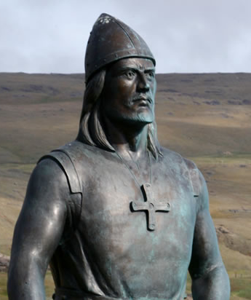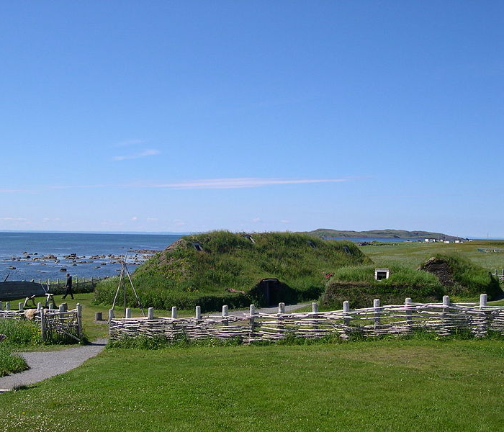
Statue of Leif Ericson (left) and a recreation of the Viking settlement at L'Anse aux Meadows (right)

The Norse: The story of the Viking exploration is contained in the sagas that passed by word-of-mouth from one generation to another before being committed to paper. Eric the Red founded Iceland and Greenland, establishing small communities there. His son, Leif Ericson voyaged from Greenland for lands sighted to the west. He then landed on the shores of a beautiful place he named Vinland (Vine land), later renamed Newfoundland. After passing a mild winter in Vinland, Ericson and his men returned to Greenland. Few people ever returned to Vinland, which is why Europe remained almost totally in the dark about the discovery of this new world. In 1960, undeniable proof of Vikings in North America came to light at L’Anse aux Meadows in Newfoundland, Canada. Several Norse Viking pieces and clear Icelandic- style house foundations gave proof positive that Vikings had indeed landed, and briefly settled, in North America 500 years before Columbus.
Estimated Arrival: 1000 A.D.

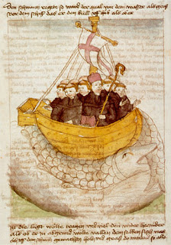
St. Brendan and the Whale, from a 15th century manuscript

St. Brendan – St. Brendan, one of the most well-known Irish Saints, is chiefly renowned for his legendary journey to the Isle of the Blessed as described in the ninth century Voyage of St Brendan the Navigator. Many versions exist that tell of how he set out onto the Atlantic Ocean in a leather-sided boat with sixty pilgrims searching for the Garden of Eden. On his trip, Brendan is supposed to have seen Saint Brendan's Island, a blessed island covered with vegetation. The most commonly illustrated adventure is his landing on an island which turns out to be a giant sea monster called Jasconius. There is speculation that the Isle of the Blessed was actually North America. Optimistic interpreters see possible evidence of the author’s knowledge of far northern sea ice, the vast Eastern Woodlands, and even the low sandy islands of the Bahamas. Unlike the Vikings, there is no settlement that proves the Irish were here prior to other Europeans.
Estimated Arrival: 512-530 A.D.
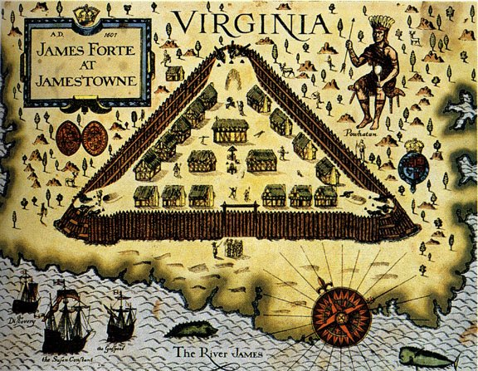
An artist’s depiction of Jamestown in 1607, including the fort and might of the Powhatan tribe

Jamestown - Chartered by James I of England, the colony of Jamestown was sponsored by the Virginia Company of London as a joint-stock company (a group of investors who hoped to profit from the venture). The area had already been explored and briefly settled by other Englishmen who had claimed the land for the then-Queen Elizabeth I, the Virgin Queen. Three ships, Susan Constant, Discovery, and Godspeed, arrived on the shores of Virginia in April of 1607 with 104 passengers. Serious problems soon emerged in the small English outpost, which was located in the midst of a chiefdom of about 14,000 Algonquian-speaking Indians ruled by the powerful leader Powhatan. An unfamiliar climate, poor water supply, lack of food, and an insufficient workforce, led to disease and death and the near failure of the colony. Through the leadership of John Smith, who instituted a “work for food” policy, the colony began to turn around. Still, drought, poor harvests, and two Anglo-Powhatan Wars threatened the survival of the colony. It wasn’t until 1613 when John Rolfe introduced a sweeter, heartier strain of tobacco to the colony that Jamestown began to turn a profit. His marriage to the Indian princess, Pocahontas, solidified the tenuous peace treaty with the Powhatans. Jamestown was the first successful, permanent settlement by the English in the Americas.
Estimated Arrival: April 1607
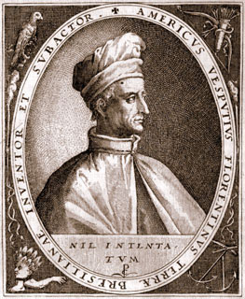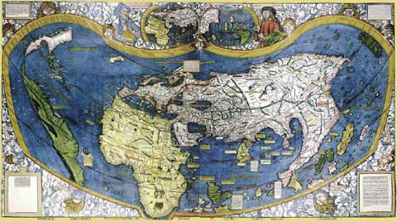
Amerigo Vespucci (left) and the first map of America, made by Martin Waldseemüller from Amerigo Vespucci's Discoveries (right)

Amerigo Vespucci – An explorer and cartographer, Amerigo Vespucci first demonstrated that Brazil and the West Indies did not represent Asia's eastern outskirts as initially believed from Columbus' voyages, but instead constituted an entirely separate landmass. He participated as an observer in several voyages that explored the east coast of South America between 1499 and 1502. The intention was to sail around the southern end of the supposed African mainland into the Indian Ocean. After hitting land at the coast of what is now Guyana (in the northern region of South America), Vespucci sailed southward, discovering the mouth of the Amazon River, before turning around and seeing Trinidad and the Orinoco River and returning to Spain by way of Hispaniola. German cartographer, Martin Waldseemüller, was the first to illustrate the newly discovered lands to the west. Basing his drawings on accounts written by Amerigo Vespucci, he named the new lands “America”.
Estimated Arrival: 1499

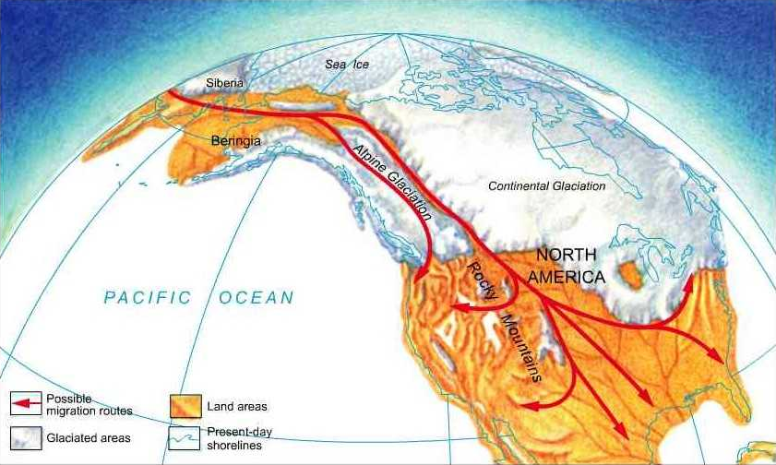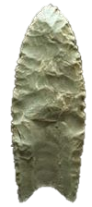
Migration patterns of Asian nomads across the Bering Land Bridge (left) and a Clovis spear head (right)

Clovis Culture – During the last Ice Age, people migrated from Siberia into Alaska, tracking big game animal herds. They were able to cross between the two continents by a land bridge called the Bering Land Bridge - an exposed land bridge that was at least 1,000 miles wide. From archaeological evidence gathered, it has been concluded that this culture of big game hunters crossed the Bering Strait at least 12,000 years ago and could have eventually reached the southern tip of South America by 11,000 years ago. This big game-hunting culture has been labeled the Clovis culture, receiving its name from artifacts found near Clovis, New Mexico. The culture is identified by the distinctive "Clovis point", a flaked flint spear-point with a notched flute by which it was inserted into a shaft; it could be removed from the shaft for traveling.
Estimated Arrival: 10,000 B.C.

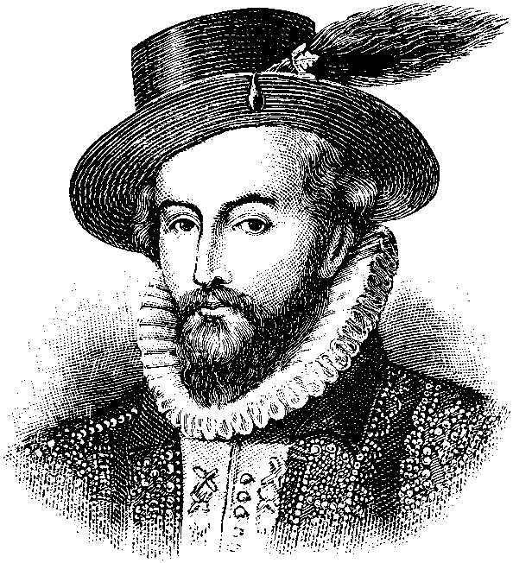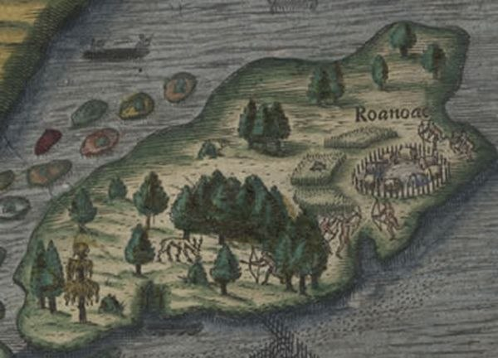
Sir Walter Raleigh (left) and the “Lost Colony” of Roanoke (right)

Sir Walter Raleigh - On March 25, 1584, Queen Elizabeth I granted Sir Walter Raleigh a charter for the colonization of the area of North America. Raleigh had earlier explored the coast of North America, claiming it for England; he named it Virginia, for Elizabeth I, the Virgin Queen. However, Raleigh did not escort the settlers of the new colony himself, but appointed his friend, John White, to lead the way. 115 men and women established the colony at the north end of Roanoke Island, which is off the coast of modern day North Carolina. The ships were to return with supplies the following year. However, a heavy winter and the epic battle against the Spanish Armada kept the supply ships from returning for three years. When White landed on August 18, 1590, he found the settlement deserted. His men could not find any trace of the 90 men, 17 women, and 11 children, nor was there any sign of a struggle or battle. The only clue was the word "Croatoan" carved into a post of the fence around the village and "Cro" carved into a nearby tree. The Croatoans were a local Native American tribe that they had traded with before the ships had originally returned to England. All the houses and fortifications had been dismantled, which meant their departure had not been hurried. White took this to mean they had moved to "Croatoan Island", but he was unable to conduct a search.
Estimated Arrival: 1585

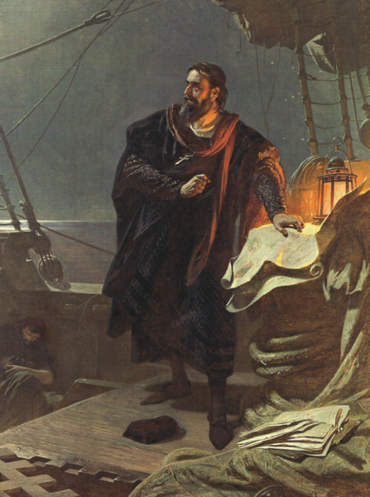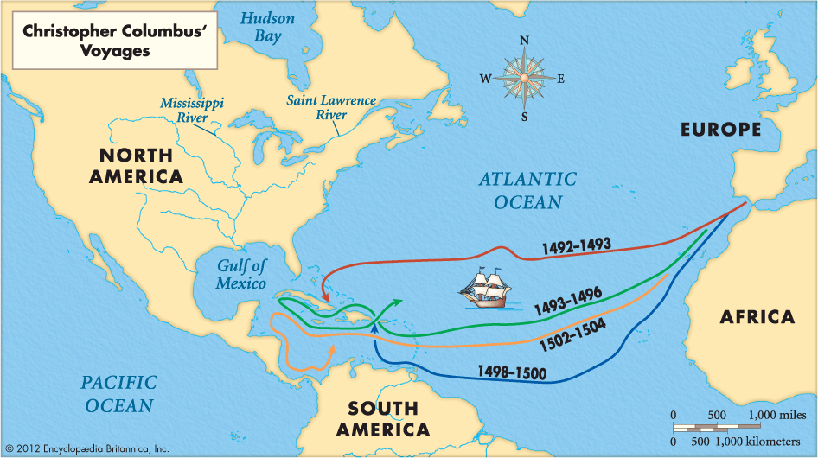
Christopher Columbus (left) and a map of his four voyages to the Americas (right)

Christopher Columbus – With the support of Ferdinand and Isabella, the monarchs of Castille (Spain), Christopher Columbus set off in three ships, the Niña, Pinta, and the Santa Maria, hoping to bypass Portugal's lock on Africa and the Indian Ocean, and reaching Asia by travelling west. After over a month at sea, land was spotted. Columbus called the island San Salvador. The indigenous people he encountered were peaceful and friendly, and believing he had reached the eastern shores of India, incorrectly called them “Indians”. Columbus visited San Salvador in The Bahamas (which he was later convinced was Japan), Cuba (which he thought was China) and Hispaniola (where he found gold). He returned to Spain with gold, exotic foods, and a handful of indigenous people to show his investors. After his activities, the major sea powers in Europe sent expeditions to the New World to exploit its riches, build trade networks and colonies, and attempt to Christianize the native people. His discoveries would be the impetus for the competition for the New World by Europe.
Estimated Arrival: October 12, 1492

